Feedback systems
- Feedback in linear analog system
According to the sign of feedback branch we recognize
- Positive feedback systems (sign plus) used in generators
- Negative feedback (minus sign) – systems used for stabilization and changing frequency characteristics
Fig. 1 Feedback analog system with negative coupling

Equivalent transfer function H(s) of these negative feedback system
$H(s)=\frac{Y(s)}{U(s)}=\frac{H_{o}(s)}{1+K(s)H_{o}(s)}$ (1)
In the case of K(s)=1 we get simplified form
$H(s)=\frac{Y(s)}{U(s)}=\frac{H_{o}(s)}{1+H_{o}(s)}$ (2)
In control systems we use the modified form of system, where G_{o}(s) represents the original plant, and K(s) the controller subsystem (Fig. 2). The open loop system is then described by H_{o}=G_{o}(s)K(s).
Fig. 2 Scheme of controller K(s) connected in cascade with the plant Go(s)

In such case the feedback system is described by
$H(s)=\frac{Y(s)}{U(s)}=\frac{K(s)G_{o}(s)}{1+K(s)G_{o}(s)}$ (3)
The open loop system transfer function is then defined as
H_{o}(s)=K(s)G_{o}(s).
In practice the following controller types are used
- Proportional controller
K(s)=k_{p} (4)
- Pproportional-integral controller (PI)
$K(s)=k_{p}\left(1+\frac{1}{T_{i}s}\right)$ (5)
- Proportional-derivative controller (PD)
$K(s)=k_{p}\left(1+T_{d}s\right)$ (6)
- Proportional-integral-derivative controller (PID)
$K(s)=k_{p}\left(1+\frac{1}{T_{i}s}+T_{d}s\right)$ (7)
- Feedback in nonlinear dynamic structure
The dynamic nonlinear systems are usually composed of linear dynamic part described by transfer function and static nonlinear subsystem. There are 3 basic connections of such subsystem: Hammerstein system, Wiener system and Hammerstein-Wiener system. Presented in Fig. 3
a)
b)
c)
Fig. 3 Typical structures of dynamic nonlinear systems: a) Hammerstein, b) Wiener, c) Hammerstein-Wiener
They differ by the sequence of linear (dynamic) and nonlinear (static) blocks. These systems may be connected in in feedback structure. Such structures can be described by the state equations. These equations start from description of dynamic linear subsystem and then takes into account the nonlinear character of the wholes system. The examples of forming such state equations are presented below.
Example 1
Describe the nonlinear Hammerstein dynamic feedback system presented in Fig. 4 by state space equations
Fig.4 Dynamic nonlinear Hammerstein feedback system

State space description of linear object H(s)

State space description of controller K(s)
The variable z is described by the nonlinear relation
Final nonlinear state space equations
Example 2
Describe the nonlinear Wiener dynamic feedback system of Fig. 5 by state space equations
Fig. 5 Dynamic Wiener nonlinear feedback system

State space description of linear subsystem
Final state equations
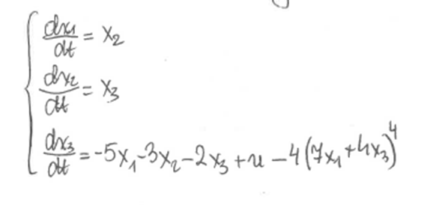
- Stability of linear analog feedback systems – Nyquist criteria
General conditions of stability of analog systems: all poles of H(s) should be located on left side of complex plane.
Stability of feedback system may be also checked by analyzing only the open loop system (transfer function Go(s)) in frequency domain s=jω (independently from analyzing the positions of poles). This is defined by Nyquist criterion. It can be applied without explicitly computing the poles and zeros of either the closed-loop or open-loop system. The Nyquist plots presents the frequency characteristic of transfer function in the coordinate system: the real part of the transfer function is plotted on the X axis, the imaginary part is plotted on the Y axis. The frequency is swept as a parameter, resulting in a plot per frequency.
The same plot can be described also in polar coordinates, where module of frequency characteristic and phase are plotted as the function of angular frequency. In such case it is called Bode plot.
2.1 Nyquist criterion
- Assume stable open loop system (poles of H_{o}(s) are in the left side of complex plane)
- Feedback system will be also stable if frequency characteristic H_{o}(s=jω) for $0≤ω<∞$ does not encircle the point (-1,j0) on the complex plane [Re(H_{o}(jω)), Im (H_{o}(jω))].
- When this characteristic H_{o}(jω) crosses point (-1,j0) then feedback system is on the border of stability (non-asymptotic type of stability)
- When characteristic H_{o}(jω) encircles point (-1,j0) feedback system is unstable.
Illustration of this criteria is depicted on Fig. 6
Fig. 6 Graphical illustration of Nyquist criteria: 1) stable feedback system, 2) system on border of stability (stable not asymptotically), 3) non-stable feedback system

- Assume non-stable open loop system (poles of H_{o}(s) are in the right side of complex plane)
In the case when some poles of open loop system are located in unstable region (right side of complex plane) the Nyquist stability criteria are given as follows.
- The feedback system built for open loop system having m poles in right side of complex plane will be stable, when the Nyquist plot of open loop system encircles the point
(-1, j0) exactly m times in counter clock wise direction.
- In other case the feedback system will be unstable.
Matlab has special function called nyquist to plot Nyquist frequency characteristic. An example of using it is presented below.
Example 3
Check stability of feedback system composed of object $G_{o}(s)=\frac{\text{10}}{3s^{3}+2s^{2}+s+1}$ and controller $K(s)=1\text{.}9s+1$.The open loop system is given by
Open loop system is unstable, since its m=2 poles are in right side of complex plane: s₁=-0.7839, s₂=0.0586 + j0.6495, s3= 0.0586 - j0.6495.
Matlab code lines solving the problem are as below
L=[19 10];
M=[3 2 1 1];
sys=tf(L,M)
nyquist(sys);

Nyquist plot is shown in Fig. 7.
Fig. 7 Nyquist plot in example 1

The Nyquist plot encircles the point (-1, j0) (red point) 2 times , so the feedback system is stable. This is confirmed by direct calculation of poles of H(s) of feedback system
$$H(s)=\frac{\left(\text{19}s+\text{10}\right)\left(3s^{3}+2s^{2}+s+1\right)}{3s^{3}+2s^{2}+\text{20}s+\text{11}}$$
The poles are as follows: s₁= -0.0558 + j2.5694, s₂= -0.0558 - j2.5694, s₃= -0.5552.

Example 4
Check stability of feedback system build on the basis of open loop system described by H_{o}(s)=L_{o}(s)/M_{o}(s), L_{o}(s)=s^3 -6s^2 + 11s -6, M_{o}(s)= s^4 + 3.8s^3 + 5.56s^2 + 5.08s + 2.32. It is stable system, since all its poles are in left side region.
Matlab command lines:
Lo=[1 -6 11 -6]
Mo=[1 3.8 5.56 5.08 2.32]
sys=tf(Lo,Mo)
nyquist(sys), grid
Nyquist plot is presented in Fig. 8.
Fig. 8 Nyquist plot in example 2. Feedback system is unstable.

This is confirmed by direct calculation of poles of feedback system, for which H(s)=L(s)/M(s), where M(s)=L_{o}(s)+M_{o}(s)= s^4+4.8s^3-0.44s^2+16.08s-3.68. Its roots (poles of feedback system) are qual: s1=-5.4458, s2=0.2096 + j1.714, s3=0.2096-j1.7140, s4=0.2266 (three poles in right side of complex plane).

2.2 Margin of stability
Margin of stability characterizes the distance of the Nyquist plot from the critical pont (-1, j0) in complex plane coordinate system. We can recognize gain margin and phase margin. Their interpretation in graphical form is presented in Fig. 9.
Fig. 9 Illustration of gain and phase margins

Gain margin is defined as
System is stable when α>1; border of stability, when α=1; unstable when α<1.
Phase margin is defined as
$Δϕ={\text{180}}^{o}+\text{arctg}\frac{Q(ω_{ϕ})}{P(ω_{ϕ})}$
where $P(ω_{ϕ})$ is real part and $Q(ω_{ϕ})$ is imaginary part of Nyquist plot of open loop system in the frequency point in which Nyquist plot crosses the unity circle.
In practice we usually require gain margin $α≥2$ ( in logarithmic scale it is 6dB) and phase margin $Δϕ≥{\text{30}}^{o}$.
Gain and phase margin can be also interpreted on Bode plots (magnitude and phase frequency characteristics). Phase margin is the angle difference between -180º and angle of phase characteristic for the frequency at which magnitude characteristic achieves value 1 (0 in logarithmic plot). Gain margin in logarithmic scale is the defined by difference between zero (real magnitude =1) and magnitude characteristic for frequency at which phase characteriztic achieves value equal -180º. The illustration of these rules are given in Fig. 10.

Fig. 10 Interpretation of stability margins on Bode plots.

Bode characteristics are created in Matlab by command bode(sys). Example of its application are shown below
L=[19 10];
M=[3 2 1 1];
sys=tf(L,M)
bode(sys), grid
Fig. 11 Bode plots of the system in example.

Remember:
Gain margin (GM) and phase margin (PM) are positive if the system is stable, negative if the system is unstable and both are zero if the system is marginally stable. Higher the GM and PM, more the system is stable.

- Discrete systems
General difference equations for nonlinear systems
$\begin{aligned}x(n+1)=f\left(x(n),u(n))\right) \\ y(n)=g\left(x(n),u(n))\right)\end{aligned}$ (6.1)
Linear system description in state space form
$\begin{aligned}x(n+1)=\text{Ax}(n)+\text{Bu}(n) \\ y(n)=\text{Cx}(n)+\text{Du}(n)\end{aligned}$ (6.2)
Interpretation of state equations of discrete system in the form of feedback structure is presented in Fig. 12.
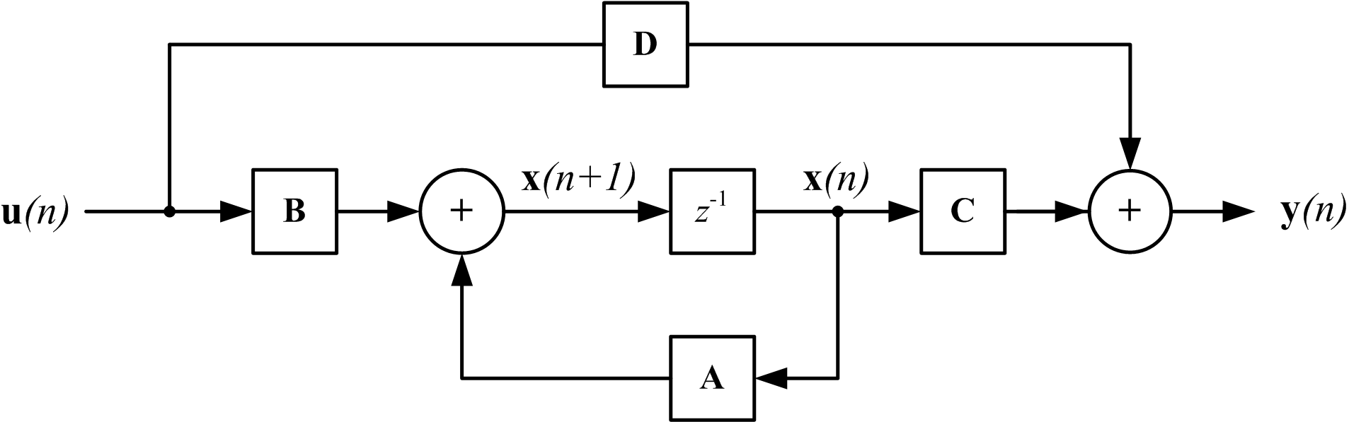
Fig. 12 The interpretation of feedback discrete form of system in state space description

Transfer function of discrete system is presented as a function of complex frequency z.
$H(z)=\frac{Y(z)}{U(z)}$ (6.6)

- Stability of discrete systems
Discrete system is stable when all its poles (roots of denominator) are inside of the unit circle.
The stability of feedback discrete system can be also checked on the basis of Nyquist plot, i.e., the plot of frequency characteristic of the open loop system H_{o}(e^{jθ}). Transfer function of feedback system defined on the basis of open loop system $H_{o}(z)=\frac{L_{o}(z)}{M_{o}(z)}$ is of the form
H(z)=H_{o}(z)/(1+H_{o}(z))
Its denominator is described now as
$M(z)=L_{o}(z)+M_{o}(z)$ (7.32)
Nyquist criterion
- Linear feedback system built on the basis of non-stable open loop system having m poles outside the unit circle will be stable, when its Nyquist plot of open loop system H_{o}(e^{jθ}) encircles m times the point (-1, j0) for θ changing from –π to π in .
- In the case of stable open loop system (all poles inside of unity circle) we have m=0. It means that feedback system will be stable, when Nyquist plot of H_{o}(e^{jθ}) does not encircle the point (-1, j0) for angle θ changing from –π to π

Matlab imlementation
Matlab has the function nyquist, which creates the Nyquist plot. The examples of its application is shown below.
- Discrete system defined by state space form
A=[1 2; 3 4], B=[0; 1], C=[ 1 4], D=1,
sys=ss(A,B,C,D,1)
nyquist(sys), grid
- Discrete system defined by transfer function
L0=[1 2],
M0=[1 0.3 0.4 0.5],
sys=tf(L0,M0,1)
nyquist(sys), grid
Example 5
Open loop system is defined by H_{o}(z)=L_{o}(z)/M_{o}(z), where L_{o}=[1 2], M_{o}=[1 0.3 0.4 0.5]. Application of Matlab command lines
L_{o}=[1 2]
M_{o}=[1 0.3 0.4 0.5]
sys=tf(Lo,Mo,1)
nyquist(sys), grid

gives the results presented in Fig. 13.
Fig. 13 Nyquist plot of stable open loop system H_{o}(z)= L_{o}(z)/M_{o}(z). Feedback system is unstable.

Open loop system of M_{o}(z)=z^3+0.3z^2+0.4z+0.is stable, since the poles are inside of unity circle p₁=0.2081 + j0.8092, p₂=0.2081 - j0.8092, p₃=-0.7162.
Feedback system of denominator M(z)=L_{o}(z)+M_{o}(z)=z^3+0.3z^2+1.4z+2.5 is unstable. This conformed by position of poles of feedback system, which are p₁= 0.3991 + j1.4551, p₂=0.3991 - j1.4551, p₃=-1.0982.

