Lecture: Modeling-simple discretization methods

General nonlinear dynamic system description in time domain is usually assumed in the state space form
in which x – state vector, u – excitation vector, y – output vector. Solving it by application of computer needs its discretization. The only explicit form of solution exists for linear system, of the general form
$$\begin{aligned}\frac{\text{dx}}{\text{dt}}=\text{Ax}+\text{Bu} \\ y=\text{Cx}+\text{Du}\end{aligned}$$
Its solution is written as follows
- Euler methods of discretization
In the case of nonlinear system described by
We have to apply more complex transformations. There are many such formulas. The simplest one is direct application of definition of derivative, by assuming finite value of variable (usually time) with respect to which the derivative is calculated. Assuming finite increase of variables we can obtain two different formulas of approximation. Let us assume the variable x under differentiation at the time point t_{n}=nT_{s} , that is x(t_{n})=x(n) and the finite increase of time t=T_{s}=h. In such case we define
- forward Euler formula (explicit)
$\frac{\text{dx}}{\text{dt}}=\frac{x(n+1)−x(n)}{T_{s}}$
From it we get immediately the explicit form of solution (for simplicity x_{n}=x(n))
$x_{n+1}=x_{n}+hf(x_{n})$
Knowing the previous solution (at the start - the initial conditions) we can immediately find the solutions in the next steps.

- backward Euler formula (implicit)
$$\frac{\text{dx}}{\text{dt}}=\frac{x(n)−x(n−1)}{T_{s}}$$
From it we get immediately the explicit form of solution in implicit form
$x_{n}=x_{n−1}+hf(x_{n})$
They represent one-step integration formulas. More advanced are multi-step Gear formulas, which approximate derivative by taking into account many time points from the past. Table 1 shows the second and third order Gear formulas as the approximation of the derivative of variable x in the time point t_{n}=nT_{s}

Table 1. Gear approximation formulas of derivative
Order of approximation | Gear formula
2 | $$\frac{\text{dx}}{\text{dt}}=\frac{3}{2T_{s}}\left[x(n)−\frac{4}{3}x(n−1)+\frac{1}{3}x(n−2)\right]$$
3 | $$\frac{\text{dx}}{\text{dt}}=\frac{\text{11}}{6T_{s}}\left[x(n)−\frac{\text{18}}{\text{11}}x(n−1)+\frac{9}{\text{11}}x(n−2)−\frac{2}{\text{11}}x(n−3)\right]$$

Example 1
As an example consider the analog RLC circuit structure presented in Fig. 5.2. We will show how to transform it into the discrete system by applying Euler rules.
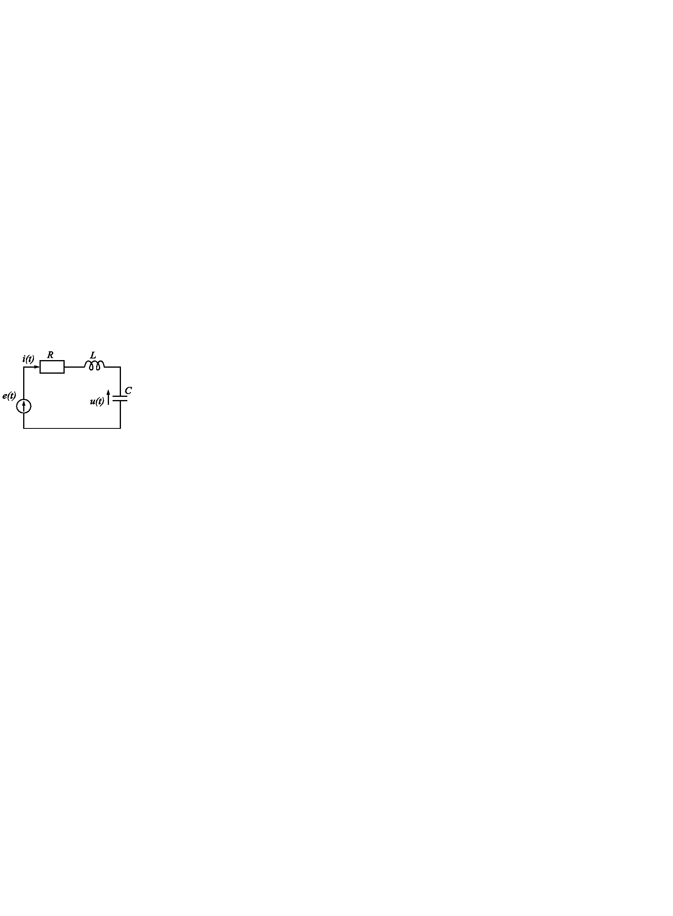
Fig. 1 The RLC circuit structure in the example.

From the Kirchhoff’s equations we can define the normal form of state space description of the circuit
$$\left[\begin{matrix}\frac{\text{di}}{\text{dt}} \\ \frac{\text{du}}{\text{dt}}\end{matrix}\right]=\left[\begin{matrix}−\frac{R}{L} & −\frac{1}{L} \\ \frac{1}{C} & 0\end{matrix}\right]\left[\begin{matrix}i \\ u\end{matrix}\right]+\left[\begin{matrix}\frac{1}{L} \\ 0\end{matrix}\right]e(t)$$
where i is the current of inductor and u voltage of the capacitor. The excitation is the voltage source e(t). Application of the forward Euler formula for t_{n}=nT_{s} changes this differential equations into the difference one described in the explicit matrix form as follows
$$\left[\begin{matrix}i(n+1) \\ u(n+1)\end{matrix}\right]=\left[\begin{matrix}1−\frac{{\text{RT}}_{s}}{L} & −\frac{T_{s}}{L} \\ \frac{T_{s}}{C} & 1\end{matrix}\right]\left[\begin{matrix}i(n) \\ u(n)\end{matrix}\right]+\left[\begin{matrix}\frac{T_{s}}{L} \\ 0\end{matrix}\right]e(n)$$
On the other side, applying the backward Euler formula leads to the implicit form of matrix description
$$\left[\begin{matrix}1+\frac{{\text{RT}}_{s}}{L} & \frac{T_{s}}{L} \\ −\frac{T_{s}}{C} & 1\end{matrix}\right]\left[\begin{matrix}i(n+1) \\ u(n+1)\end{matrix}\right]=\left[\begin{matrix}i(n) \\ u(n)\end{matrix}\right]+\left[\begin{matrix}\frac{T_{s}}{L} \\ 0\end{matrix}\right]e(n+1)$$
Thanks to the linear form of description it can be transformed to the explicit form as follows.
$$\left[\begin{matrix}i(n+1) \\ u(n+1)\end{matrix}\right]={\left[\begin{matrix}1+\frac{{\text{RT}}_{s}}{L} & \frac{T_{s}}{L} \\ −\frac{T_{s}}{C} & 1\end{matrix}\right]}^{−1}\left[\begin{matrix}i(n) \\ u(n)\end{matrix}\right]+{\left[\begin{matrix}1+\frac{{\text{RT}}_{s}}{L} & \frac{T_{s}}{L} \\ −\frac{T_{s}}{C} & 1\end{matrix}\right]}^{−1}\left[\begin{matrix}\frac{T_{s}}{L} \\ 0\end{matrix}\right]e(n)$$
Observe, that such operation is possible only for linear systems. The nonlinear systems must operate with the implicit form of state equations.
The stability of both systems (analog and discrete) depends on the eigenvalues of state matrix A. The analog linear system is stable, when all its eigenvalues are in the left-half plane of complex plane. The stability of discrete systems requires the position of poles inside of the unit circle.
The analog system composed of passive RLC elements is stable from the definition (all eigenvalues in the left-half of the complex plane). However, stability of the discrete system depends on the type of approximation. In backward methods all eigenvalues are always inside of the unit circle, which means stability. Application of forward Euler algorithm does not guarantee the stability. The position of eigenvalues depends on the assumed time step T_{s}. If it is too large the poles move outside the unit circle and the system converts to be unstable.
As an example let us take R=1Ω, L=1H, C=1F in the last example. Assuming T_{s}=1,2s we get state matrix A in backward method as follows
$$A=\left[\begin{matrix}0,\text{275} & −0,\text{329} \\ 0,\text{329} & 0,\text{604}\end{matrix}\right]$$
Its eigenvalues are equal λ₁=0.439+j0.287, λ₂=0.439-j0.287. Both eigenvalues are inside of the unit circle, hence the resulting discrete system is stable. On the other side applying this step size T_{s} in forward algorithm we get matrix A equal
$$A=\left[\begin{matrix}−0,2 & −1,2 \\ 1,2 & 1\end{matrix}\right]$$
of the eigenvalues: λ₁=0.4+j1.02, λ₂=0.4-j1.02. These eigenvalues are outside the unit circle, hence, the discrete system is unstable. It can be stabilized reducing appropriately time step. For example at T_{s}=0,6s we get the matrix A equal
$$A=\left[\begin{matrix}0,4 & −0,6 \\ 0,6 & 1\end{matrix}\right]$$
The eigenvalues of this matrix are now: λ₁=-0.7+j0.52, λ₂=-0.7-j0.52. All of them are inside of the unit circle (stable system).
The value of the discretization step T_{s} is important also for accuracy of approximation. Fig. 5.3 shows the results of approximation of the current i(t) at different values of T_{s} and application of backward and forward approximations. The backward algorithm delivers the stable results irrespective of the applied sampling period. However, the accuracy of solution depends on the size of discretization step.
Different situation is in the case of forward algorithm. It might be unstable, if too long sampling period is applied. This is well illustrated in Fig. 5.3, presenting the results for T_{s}=0.02s, 0.6s and 1.2s. At T_{s}=1.2s the extrapolation (forward) algorithm has resulted in unstable solution, while the interpolation (backward) was stable, although the least accurate.
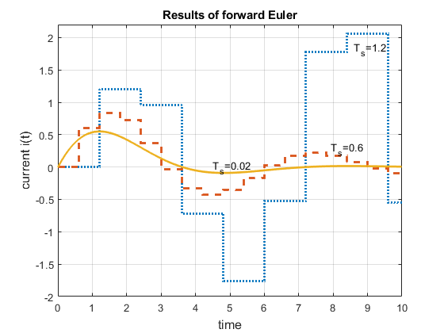
a)
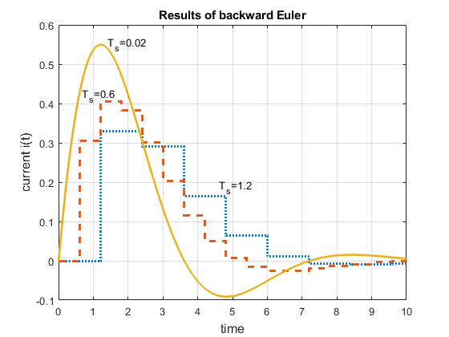
b)

Fig. 2. Solution for i(t) in the circuit of Fig. 5.2 at application of: a) Euler forward, b) Euler backward algorithms at different lengths of sampling period T_{s}=0.021s, 0.6s and 1.2s.

- Trapezoidal rule
According to the trapezoidal method, solution x(t) of dx/dt=f(t,x) in the discrete time point t=nT_{s} can be written in the form (x(n)= x_{n}, x(n-1)= x_{n-1})
$$x_{n}=x_{n−1}+\frac{T_{s}}{2}\left[\frac{{\text{dx}}_{n}}{\text{dt}}+\frac{{\text{dx}}_{n−1}}{\text{dt}}\right]$$
It means that the next step solution depends on itself. It is well seen from the modified form of this equation
x_{n}=x_{n-1}+0.5T_{s}[f(t_{n},x_{n})+f(t_{n-1},x_{n-1})]
The value x_{n} on the left side of equation depends on itself (on the right). So, it is also of implicit form, which needs special procedure of prediction (application of explicit method) delivering the starting point for correction.
Writing implicit form solution as x_{n}=F(x_{n}) we calculate first the initial value $x_{n}^{(0)}$ from explicit form (for example Euler forward – only one iteration) and then correction from implicit method
$x_{n}^{(k)}=F\left(x_{n}^{(k−1)}\right)$ (6.8)
for k = 1, 2, ... until stabilization of x_{n}.

3.Runge-Kutta methods
Runge-Kutta methods represent special numericl implementation of Taylor expansion for solution of differential equation dx/dt=f(t,x). The method is based on Taylor expansion of the variable x in the neighborhood of previous point
They have been defined for 2nd and 4th orders and represent 1-step integration method.
The classical second order RK method of fixed step h is described by the following equations
$\begin{aligned}k_{1}=f(t_{n},x_{n}) \\ k_{2}=f(t_{n}+h,x_{n}+k_{1}) \\ x_{n+1}=x_{n}+\frac{h}{2}\left[k_{1}+k_{2}\right]\end{aligned}$
It is called also Heune method. The local error is proportional to third power of h, 0(h³).
This error can be significantly reduced by applying 4th order RK formula. It can be presented as the following sequence of computations.
The solution in n+1 step depends only on its previous solution x_{n} – hence the name 1-step method. It is explicit formula, which can be used as the predictor in predictor-corrector methods. The local error is now proportional to 5th power of h, 0(h⁵).
RK methods can be made more effective by applying variable step h, adjusted to the actual solution (steep signals require small h, non-steep accept larger values of h). The problem is how to estimate an error not increasing the time of computation. This solution was developed by Fehlberg, and then by other mathematicians: Dormand-Prince, Bogacki-Shampine. All these approaches extend calculations from 2nd to 3rd (RK23) and from 4th to 5th order (RK45). Higher order solution is needed to estimate the actual local error of approximation.
The general sequence of calculations in variable step RK45 algorithm (Fehlberg version) is as follows
k₁=hf(t_{n},x_{n})
k₂=hf(t_{n}+a₂h,x_{n}+b₂₁k₁)
k₃=hf(t_{n}+a₃h,x_{n}+b₃₁k₁+ b₃₂k₂)
………………………..
k₆=hf(t_{n}+a₆h,x_{n}+b₅₁k₁+ b₆₂k₂+…+b₆₅k₅)
On the basis of this we calculate two next step solutions, allowing to estimate an error
x_{n+1,5}=x_{n}+c₁k₁+c₂k₂+…+c₆k₆ = x_{n+1}
of the local error proportional to h⁶ and
x_{n+1,4}=x_{n}+d₁k₁+d₂k₂+…+d₆k₆
of the local error proportional to h⁵. Estimation of error is defined as follows
Δ= x_{n+1,5}- x_{n+1,4}
The values of coefficients a_{i}, b_{ij}, c_{i}, d_{i} in these equations have been specially chosen by authors of this modification. On the basis of this error Δ, the next step length h₁ is estimated, taking into account that Δ is proportional to h⁵, i.e.,
(Δ₁/Δ₀)= (h₁/h₀)⁵
From which we get
h₁= h₀ (Δ₁/Δ₀)^{1/5}
Δ₁ represents the needed local error in next step, and Δ₀ the actual one. Similar meanings are for the steps h₁ and h₀.
The following equations have been defined for RK23 in variable step method
k₁=hf(t_{n},x_{n})
k₂=hf(t_{n}+h,x_{n}+k₁)
k₃=hf(t_{n}+0.5h,x_{n}+(k₁+k₂)/4)
On the basis of this we calculate two next step solutions, allowing to estimate the actual local error
x_{n+1,3}=x_{n}+(k₁+k₂+4k₃ )/6 = x_{n+1}
of the local error proportional to h⁴ and
x_{n+1,2}=x_{n}+(k₁+k₂)/2
of the local error proportional to h³. Estimation of error is defined as follows
Δ= x_{n+1,3}- x_{n+1,2}
On the basis of this error Δ, the next step length h₁ is estimated
h₁ =h₀ (Δ₁/Δ₀)^{1/3}
In this way both RK45 and RK23 methods allow to perform calculations with the step adjusted to the needed value in the next step. These variable RK methods are regarded as very universal. however, they fail in more demanding cases, for example stiff system of differential equations.

