Lecture: Description of analog dynamic systems
Analog dynamic system is described by the system of differential equations using the concept of so called state variables. A state variable is one of the set of variables that are used to describe the mathematical "state" of a dynamical system. The state of a system describes the system to determine its future behaviour in the absence of any external forces affecting the system, resulting from non-zero initial conditions. State variables are grouped in a state vector x=[x₁, x₂,...x_{n}]. The state variables should allow to describe uniquely all other variables in the system. Therefore, they should be continuous in time, i.e., x(t⁺)=x(t⁻). In electrical engineering the state variables are associated with coil curren (or flux) and capacitor voltage (or charge).
We will use the minimum number of such internal variables of the system, which allow to define all needed external variables grouped usually in vector y=[y₁, x₂,...x_{M}]. The external excitations of the system will be denoted by vector u=[u₁, u₂,...u_{N}]. Typical description of analog (continuous time) process in the form of state equations in normal form
(1)
where x represents the vector of state variables , u – input excitations, and t represent the dependence of parameters on time (in the case of non-stationary system)
The output variable gathered in vector y depend in general on x and excitation vector u
y=g(x,u,t) (2)

- Nonlinear system description
The general form description (1) can be presented in the extended form as follows
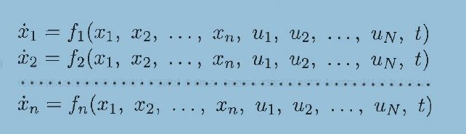 (3)
The general solution form of it is given as follows

Its direct anlytical solution does not exist. Instead it is solved using discretization in time by applying short increment Δt. As a result te variables are now presened in incremental form
Assume at the equilibrium. $f(\tilde{x},\tilde{u})=0$. Moreover dx/dt=dΔx/dt and Taylor series $\frac{dx}{\text{dt}}=\frac{dΔx}{\text{dt}}=\frac{∂f}{∂x}\text{Δx}+\frac{∂f}{∂u}\text{Δu}$
and
$y=\tilde{y}+\text{Δy}=\tilde{y}+\frac{∂y}{∂x}\text{Δx}+\frac{∂y}{∂u}\text{Δu}$.
Hence we get
$\begin{aligned}\frac{dΔx}{\text{dt}}=A(t)\text{Δx}+B(t)\text{Δu} \\ Δy=C(t)\text{Δx}+D(t)\text{Δu}\end{aligned}$ (2.8)
where A(t), B(t), C(t) i D(t) are Jacoby matrices
$A(t)=\frac{∂f}{∂x}=\left[\begin{matrix}\frac{∂f_{1}}{∂x_{1}} & \frac{∂f_{1}}{∂x_{2}} & ⋯ & \frac{∂f_{1}}{∂x_{n}} \\ \frac{∂f_{2}}{∂x_{1}} & \frac{∂f_{2}}{∂x_{2}} & ⋯ & \frac{∂f_{2}}{∂x_{n}} \\ ⋯ & ⋯ & ⋯ & ⋯ \\ \frac{∂f_{n}}{∂x_{1}} & \frac{∂f_{n}}{∂x_{2}} & ⋯ & \frac{∂f_{n}}{∂x_{n}}\end{matrix}\right]$ (2.9)
$B(t)=\frac{∂f}{∂u}=\left[\begin{matrix}\frac{∂f_{1}}{∂u_{1}} & \frac{∂f_{1}}{∂u_{2}} & ⋯ & \frac{∂f_{1}}{∂u_{N}} \\ \frac{∂f_{2}}{∂u_{1}} & \frac{∂f_{2}}{∂u_{2}} & ⋯ & \frac{∂f_{2}}{∂u_{N}} \\ ⋯ & ⋯ & ⋯ & ⋯ \\ \frac{∂f_{n}}{∂u_{1}} & \frac{∂f_{n}}{∂u_{2}} & ⋯ & \frac{∂f_{n}}{∂u_{N}}\end{matrix}\right]$ (2.10)
$C(t)=\frac{∂g}{∂x}=\left[\begin{matrix}\frac{∂g_{1}}{∂x_{1}} & \frac{∂g_{1}}{∂x_{2}} & ⋯ & \frac{∂g_{1}}{∂x_{n}} \\ \frac{∂g_{2}}{∂x_{1}} & \frac{∂g_{2}}{∂x_{2}} & ⋯ & \frac{∂g_{2}}{∂x_{n}} \\ ⋯ & ⋯ & ⋯ & ⋯ \\ \frac{∂g_{m}}{∂x_{1}} & \frac{∂g_{m}}{∂x_{2}} & ⋯ & \frac{∂g_{m}}{∂x_{n}}\end{matrix}\right]$ (2.11)
$D(t)=\frac{∂g}{∂u}=\left[\begin{matrix}\frac{∂g_{1}}{∂u_{1}} & \frac{∂g_{1}}{∂u_{2}} & ⋯ & \frac{∂g_{1}}{∂u_{N}} \\ \frac{∂g_{2}}{∂u_{1}} & \frac{∂g_{2}}{∂u_{2}} & ⋯ & \frac{∂g_{2}}{∂u_{N}} \\ ⋯ & ⋯ & ⋯ & ⋯ \\ \frac{∂g_{m}}{∂u_{1}} & \frac{∂g_{m}}{∂u_{2}} & ⋯ & \frac{∂g_{m}}{∂u_{N}}\end{matrix}\right]$ (2.12)
Linearization of the stationary nonlinear system results in the non-stationary linear system with the state matrices dependent on time.

Example 1
Consider the nonlinear electrical circuit described by
$$\begin{aligned}i_{R}=u_{R}^{3}−3u_{R} \\ i_{L}=ψ^{3}−3ψ\end{aligned}$$
Fig. 1 Circuit structure
From Kirchhoff’s laws we get
Assume stet vector $x={\left[u_{C} ψ\right]}^{T}$, in such case we get final description in the form
$$\begin{aligned}\frac{{\text{du}}_{C}}{\text{dt}}=\frac{1}{C}\left(i−u_{C}^{3}+3u_{C}−ψ^{3}+3ψ\right) \\ \frac{dψ}{\text{dt}}=u_{C}\end{aligned}$$
- Linear dynamic systems
In the case of linear stationary dynamic systems the description is similar to the linearized form, however, with constant matrices A, B, C and D. Its normal form is given as follows
Its general form solution is relatively easy and given in the form
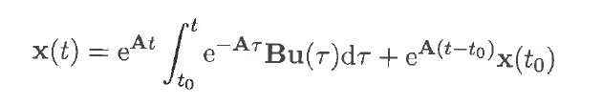
The detailed solution form depends on the eigenvalues of the matrix A. The eigenvalues are the roots s_{i} (i=1,2,3,.., n) of the polynomial det(s1-A)=0.

- Stability of dynamic systems
There are different definitions of stability of dynamic systems. In the case on non-autonomous systems (systems with existing external excitations) the most often used is so called BIBO stability (bounded input – bounded output). System is BIBO stable, when ah bounded excitation u the output variables (vector y) are always bounded irrespective of time, i.e. for $t→∞$ the output y(t) is limited when input u(t) is limited.
The second type of stability is Lyapunow stability. Its notion is strictly associated with the concept of equilibrium point, i.e., the point, in which dx/dt=0. There are two types of it:
- Local stability
- Global stability
Local stability of the system assumes, that the system is stable for initial conditions very close to the equilibrium point. It means that small perturbation of the state results in automatic return of the operating point into equilibrium.
Global stability means, that system returns to the equilibrium point irrespective of the initial conditions, which might be placed at any position of space. Arbitrary large perturbation automatically is ended at the equilibrium point.
Asymptotic stability means, that for $t→∞$ the state x(t) tends to zero point, i.e., $\underset{t→∞}{\text{lim}}x(t)=0$ (from definition there is no external excitation).
Stability of the system is defined on the basis of its internal behaviour of state variables (the limited value excitation has nothing to do with this notion). Therefore in further considerations we will assume u(t)=0.

- Linear systems
Consider first the linear system. Its solution for state variable x(t) (at u=0) is given in the form
The time response depends solely on the positions of the eigenvalues of matrix A. In the case of all single poles s_{i} we can write
In the case of multiple poles the time response can be presented as follows
From these two equations it is seen that linear analog system of single eigenvalues will be stable when all its eigenvalues have negative real part (are place on the left side of complex plane). If at least one eigenvalue is on the right side of complex plane the system is not stable. In the case when some poles are on the imaginary axis, the system will be stable, when such poles are single, or not stable, when they are multiple. This is illustrate din Fig. 2.
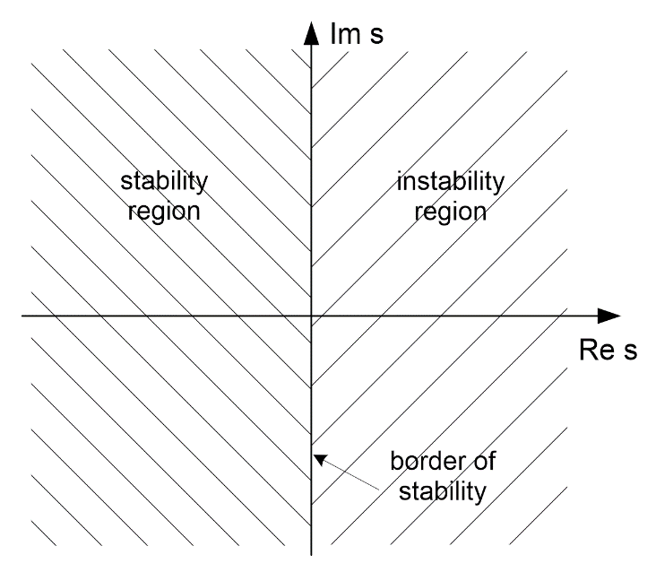
Fig. 2. Illustration of stability region on complex plane
- Nonlinear systems
Local stability of nonlinear system is based on its linearized model around equiibrium point (so called first Lyapunov principle). In such case the nonlinear system is represented by its linearied version of the matrices A, B, C and D. The stability depends on the position of eigenvalues of state matrix A. The system is locally stable if all its eigenvalues have negative real part (are place on the left side of complex plane). If at least one eigenvalue is on the right side of complex plane the system is not stable. In the case when some poles are on the imaginary axis, the stability of nonlinear system is not defined on the basis of its linearization.
Global stability checking is much more difficult. Its assessment is made using second Lyapunov principle. According to it the nonlinear system described by dx/dt=f(x) is asymptotically stable in equilibrium point x=0 in glonal sense, if it is possible to define the positively defined function V(x) satisfying the condition

- V(x) →∞ at x →∞
- derivative $\frac{\text{dV}(x)}{\text{dt}}$is negatively defined for all x.
- if $\frac{\text{dV}(x)}{\text{dt}}$ is non-positive define (negative or zero values) the system is stable but not asymptotically
Function V(x) is most often defined in quadratic form of all elements x_{i} of vector x, i.e.,
$V(x)=\frac{1}{2}\left(x_{1}^{2}+x_{2}^{2}+⋯+x_{n}^{2}\right)$ (3.16)
Sometimes this function is defined also in an extended form
$V(x)=\frac{1}{2}\left(x_{1}^{2}+x_{2}^{2}+⋯+x_{n}^{2}\right)+\int_{0}^{l}{g(η)dη}$ (3.17)
where g(η) is user defined function.
Example 2
As an example consider the nonlinear system described by Duffing equation of the form
$$\frac{d^{2}x}{{\text{dt}}^{2}}+a\frac{\text{dx}}{\text{dt}}+x+b{\left(\frac{\text{dx}}{\text{dt}}\right)}^{{}_{3}}=0$$
First we transform it to state space form
$$\frac{d^{2}x}{{\text{dt}}^{2}}=\frac{{\text{dx}}_{2}}{\text{dt}}=−{\text{ax}}_{2}−x_{1}−{\text{bx}}_{2}^{3}$$
Hence
$$\begin{aligned}\frac{{\text{dx}}_{1}}{\text{dt}}=x_{2} \\ \frac{{\text{dx}}_{2}}{\text{dt}}=−{\text{ax}}_{2}−x_{1}−{\text{bx}}_{2}^{3}\end{aligned}$$
Lyapunov function is defined as following
$V(x)=\frac{1}{2}\left(x_{1}^{2}+x_{2}^{2}\right)$
It is easy to show, that $V(x)→∞$ for $x→∞$. The second condition dV(x)/dt
$$\begin{aligned}\frac{\text{dV}(x)}{\text{dt}}=\frac{\text{dV}(x)}{{\text{dx}}_{1}}\frac{{\text{dx}}_{1}}{\text{dt}}+\frac{\text{dV}(x)}{{\text{dx}}_{2}}\frac{{\text{dx}}_{2}}{\text{dt}}=x_{1}x_{2}+x_{2}(−{\text{ax}}_{2}−x_{1}−{\text{bx}}_{2}^{3}) \\ \frac{\text{dV}(x)}{\text{dt}}=−({\text{ax}}_{2}^{2}+{\text{bx}}_{2}^{4})\end{aligned}$$
Condition of global stability is now
${\text{ax}}_{2}^{2}+{\text{bx}}_{2}^{4}>0 → x_{2}^{2}>−\frac{a}{b}$
Assuming additionally że a>0 i b>0 we get stable operation of the system without any other condition (system totally stable).

3.Transformations of linear system descriptions
The general description of linear system is given in the form
$$\begin{aligned}\frac{dx}{\text{dt}}=\text{Ax}+\text{Bu} \\ y=\text{Cx}+\text{Du}\end{aligned}$$
where $A∈R^{n×n}$, $B∈R^{n×N}$, , .
Behaviour of this system depends the most on the eigenvalues of matrix, i.e., the roots of the polynomial det(s1-A)=0. The solution of the state description is given as follows
$$x(t)=e^{\text{At}}\int_{t0}^{t}{e^{−Aτ}\text{Bu}(τ)dτ+e^{A(t−t_{0})}}x(t_{0})$$
There are many methods to find its explicit form, all depnds on the calculation of the matrix e^{At}. However, assuming autonomous system (u=0) this solution might be written as follows
- when all eigenvalues s_{i} are single
$x(t)=\sum_{i=1}^{n}{K_{i}e^{s_{i}t}}$ (3.27)
- for multiple eigenvalues
$x(t)=\sum_{i=1}^{n}{K_{i}e^{s_{i}t}+}\sum_{k=1}^{n_{{}_{1}}}{F_{k}{\text{te}}^{s_{k}t}+}\sum_{r=1}^{n{}_{2}^{}{}}{G_{r}t^{2}e^{s_{r}t}+}⋯$
Fig. 3 presents typical impulse responses of the linear dynamic systems at different positions of the eigenvalues.

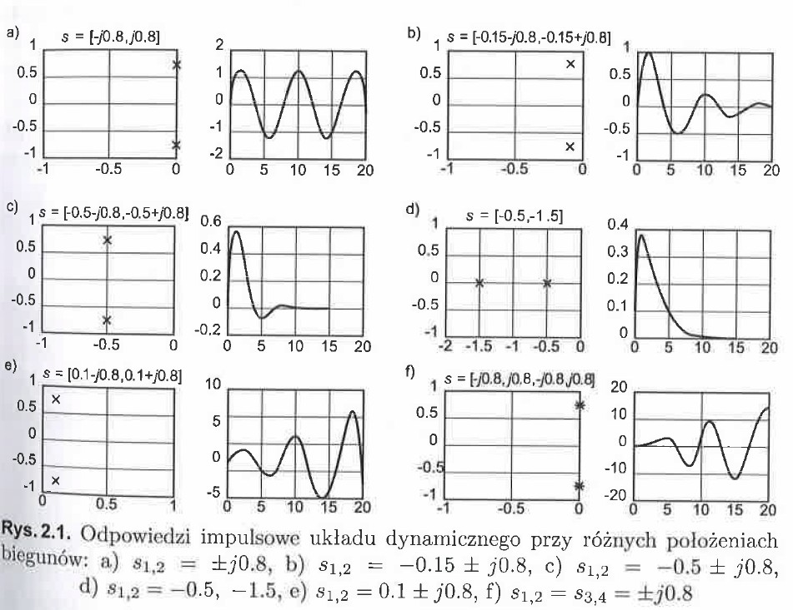
Fig. 3 Typical impulse responses at tdifferent positions of eigenvalues:

Assuming for non-autonomous system one input (N=1) and one output (M=1) the state space can be easily transformed to so called transfer function description H(s), where
In the case of typical systems of constant parameters the transfer function H(s) takes the normalized rational form
Both descriptions (state space and rational) can be transformed to each other. In the case H(s) to state form there are many different transformations. Below please find two of them for l<n.
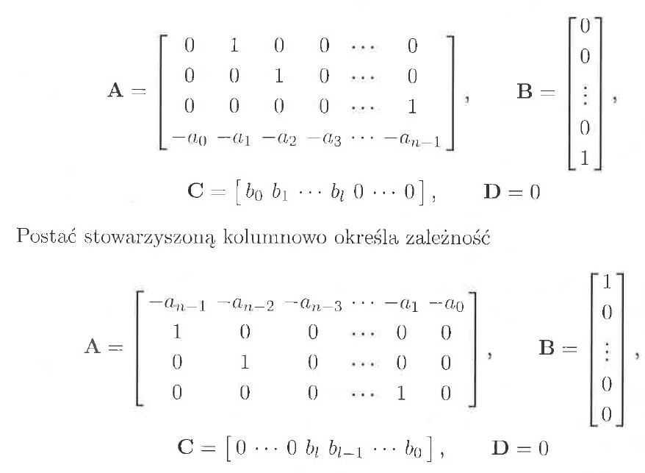
And
The other form of transfer function is so called zero-pole description (poles are the roots of denominator of H(s), which are the same as eigenvalues of matrix A). It is usually defined in the form
There are many different functions in Matlab performing such transformations. Among them there are
[A,B,C,D]=tf2ss(Num, Den)
[A,B,C,D]=zp2ss(z,p,k)
[Num,Den]=ss2tf(A,B,C,D)
[Num,Den]=zp2tf(z,p,k)
[z,p,k]=ss2zp(A,B,C,D)
[z,p,k]=tf2zp(Num,Den)

- Algebraic criteria of stability of linear systems
4.1 Hurwitz criteria
Let us assume the denominator M(s) in the form
$M(s)=a_{n}s^{n}+a_{n−1}s^{n−1}+⋯a_{1}s+a_{0}$ (4.1)
The linear system H(s)=L(s)/M(s) is stable if all roots of M(s) are in the left side of complex plane. Such polynomial is called Hurwitz polynomial. Let us define Hurwitz matrix
Hurwitz matrix:
$$H_{n}=\left[\begin{matrix}a_{n−1} & a_{n} & 0 & 0 & ⋯ \\ a_{n−3} & a_{n−2} & a_{n−1} & a_{n} & ⋯ \\ a_{n−5} & a_{n−4} & a_{n−3} & a_{n−2} & ⋯ \\ ⋮ & ⋮ & ⋮ & ⋮ & ⋯ \\ 0 & 0 & 0 & 0 & a_{0}\end{matrix}\right]$$
and define the following main minors (determinants)
$Δ_{1}=a_{n−1}$,
$$Δ_{2}=\left|\begin{matrix}a_{n−1} & a_{n} \\ a_{n−3} & a_{n−2}\end{matrix}\right|$$
$$Δ_{3}=\left|\begin{matrix}a_{n−1} & a_{n} & 0 \\ a_{n−3} & a_{n−2} & a_{n−1} \\ a_{n−5} & a_{n−4} & a_{n−3}\end{matrix}\right|$$
$$Δ_{m}=\text{det}(H_{m})$$
Linear system of M(s) is stable when all coefficients a_{i} exist and are positive, and also all main minors (determinants) are positive, i.e. Δ₁>0, Δ₂>0,…, Δ_{n-1}>0.:
Example 4.1
Determine stability of the system, when M(s)= s³ + s² + 4s + 20
- All a_{i} are positive
- Determinants Δ₁ i Δ₂
Δ₁= 1>0
$$Δ_{2}=\left|\begin{matrix}1 & 1 \\ \text{20} & 4\end{matrix}\right|=−\text{16}$$
Second minor is not positive. System is not stable.
Example 4.2
What is condition for k to provide stable operation of the system described by M(s)
M(s)= s⁴ + 2s³+ks² + 4s + 5
- All coefficients should be positive, hence k>0.
- Determinants
System will be stable when k>4.5.

Problems with Hurwitz criteriakryterium Hurwitza:
- There is a need to calculate the determinants up to n-1 order
- Complexity of calculation of determinant of order k is proportional to k².
- Very complex application for higher order systems

4.2. Routh criteria
In Routh criteria we need to calculate only determinants of second orders (k=2)
Calculations in Routh criteria are in the following order
- Check if all coefficients a_{i} of M(s) are positive.
- Form 2 first rows of Routh array in the way
- Fill in the Routh array in the form:
The elements of other rows are calculated according to the following formulas:
The number of rows of the Routh array is equal to the number of elements of M(s) (degree of polynomial plus 1). The last row contains only a₀.
- Based on the Routh array stability conditions are as follows:

- Dynamic system is stable, when all a_{i} of M(s) exist and are positive and at the same time
all elements of the left column of the Routh array are positive
- If some elements of this left column are negative, system is unstable. The number of changes of the sigh (positive to negative or vice versa) is equal to the number of poles located in the right side of the complex plane.

Example 4.3
The system is described by M(s) in the following form:
M(s)= 2s⁴ + s³+3s² +5s + 10
- The first condition (a_{i}>0) is fulfilled.
- Building the Routh array
The first two rows are as follows
$\begin{matrix}2 & 3 & \text{10} \\ 1 & 5 & 0\end{matrix}$
The next elements are calculated as below
Hence the Routh array is of the form:

There are 2 changes of sign in the left column of array, therefore the system is unstable..
According to Mtalab the roots of M(s) are as loffows (roots(M))
bieguny=[0.7555+1.4444i; 0.7555-1.4444i; -1.0055+0.9331i; -1.0055-0.9331i

