Lecture: Dynamic macromodel of power systems for frequency stabilization

- Basic system of power generation
The key problem in electrical energy generation is stabilization of frequency (stabilization of speed of the generator). The automatic system of frequency control is based on feedback system with PI controller. Fig. 1 presents the general structure of power system generation.

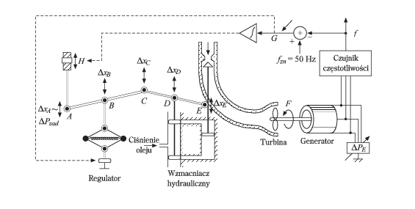

Fig. 1 The general scheme of electrical energy generation system

Basic blocks:
Generator
Turbine (Polish: Turbina)
Hydraulic amplifier-actuator (Polish: Wzmacniacz hydrauliczny)
Frequency sensor (Polish: Czujnik częstotliwości)
Integrating controller
Proportional controller built into the system
The proportional controller is responsible for changing position of x_{B} in proportion to change of frequency Δf
${Δx}_{B}=\frac{1}{R}Δf$ (9.1)
The integrating controller reacts on the sum of changes of frequency over time and controlls the ΔH, where
$ΔH=K_{i}\int{Δ\text{fdt}}$ (9.2)
Both P and I controllers are in negative feedback with the whole system.
All elements of power system represent nonlinear units. Their models are quite complex. Therefore, we use their linearized models of the first order. Linearization is made in nominal operating point of the units. Remember, in this model we operate with the increments of particular variables, not their real values. Their linearized model description is shown in Table 1.

Table 1 Linearized models of the elements of power system
Element | Transfer function
P controller | 1/R
I controller | -K_{i}/s
Hydraulic actuator | K_{h}/(1+sT_{h})
Turbine | K_{t}/(1+sT_{t})
Generator | K_{p}/(1+sT_{p})

The typical values of their parameters for the power system of 1000MW are:
K_{h}=K_{t}=1.0, K_{p}=120Hz/MW,
T_{h}=80ms, T_{t}=0.3s, T_{p} = 20s,
R=2.4Hz/MW.

Fig. 2 presents the connection of particular blocks forming the power system model in complex frequency domain.

Fig.2 Linearized macromodel of power system

The output signal of the model Δf(s), represents Δf = f(t) − 50, and this difference of the frequency controls the operation of the whole system through PI controller. The crucial point is the choice of the value of K_{i} of PI controller. Fig.3 shows the change of frequency with time at abrupt loading the system in time t=1s at different values of K_{i}, from 0 to Ki=-0.5. The optimal set is the value which guarantee the shortest time of transient.
Fig. 3 The changes of actual frequency of the system at different values of K_{i}.

- Cooperation of two power systems
In real country power system there are many generating units cooperating with each other. Fig. 4 shows the connection of 2 generating units in cooperation.
.
Fig. 4 The connection of 2 cooperating power systems
The important is the automatic reaction of one unit to the need of help of the other unit. The unit of abruptly increased load reacts with the slowing speed of generator (drop in frequency). Two generating units (formerly synchronized with the same angle θ₁ = θ₂ of the shaft) experience now their difference, which controls the flow of the supporting power from one unit to the other one. This flow is described by

$${ΔP}_{\text{12}}(s)=T_{0}\left[{Δθ}_{1}(s)−{Δθ}_{2}(s)\right]$$
Where T₀=0.0707[MW/rad]. Taking into account
$Δθ=\int{2πΔ\text{fdt}}$ ->
the last equation is transformed to
$${ΔP}_{\text{12}}(s)=2{πT}_{0}\left[\frac{{Δf}_{1}(s)}{s}−\frac{{Δf}_{2}(s)}{s}\right]$$
Fig. 5 presents the transfer function model of these two cooperating units.

. Fig.5 Transfer function model of 2 cooperating units.

Fig.6 illustrates the changes of local frequencies of both subsystems and the flow of balancing power from one system to the other for two choices of K_{i} values of both system.At K_{i}=0 there is no self-regulation of individual systems and the regulating flow of power is constant. Returning K_{i} to the proper value (here K_{i}=-0,25) allows the sel-regulation of the systems and the automatic flow of balancing power stops after some transient time.
Fig.6 The changes of local frequency of 2 cooperating generators and flow of balancing power

Fig. 7 presents the cumulated changes of the loads of 2 cooperating power systems and the changes of local frequency and corresponding flow of balancing powers.

Fig. 7 The illustration of the changes of local frequency and flow of balancing power in 2 cooperating systems

Example
Convert Laplace model of power system to state space description. Transfer function model is presented as follows
The solution starts from the definition of transfer function
State space model

